
Session: 2025 - 2026
Company: Unified Mentor Pvt. Ltd.
Duration: 45 Days
College: Jodhpur Institute of Engineering and Technology
Submitted To: Unified Mentor
Submitted By: Lakshdeep Singh
Project Title: Intrusion Detection System
Machine Learning
INTERNSHIP PROJECT REPORT

Table of Contents
- Acknowledgement
- Abstract
- Introduction
3.1 Internship Overview at Unified Mentor Pvt. Ltd.
3.2 Primary Objectives
3.3 Project Scope
- Company Profile
4.1 Background and History
4.2 Mission and Vision
4.3 Products and Services
4.4 Organizational Structure
- Project Description
5.1 Problem Statement
5.2 Objectives
5.3 Tools and Technologies Used
5.4 Methodology
- Work Performed
6.1 Step-by-Step Implementation
6.2 Diagrams and Workflow
- Challenges Faced and Solutions
- Result and Analysis
8.1 Model Performance Metrics
8.2 Feature Importance Analysis
- Learning Outcomes
- Conclusion
- References
11.1 Books
11.2 Online Resources
11.3 Software Tools
- Appendix
12.1 Performance Comparison Table
12.2 Project Screenshots and Code Snippets

Acknowledgement

I would like to express my sincere and heartfelt gratitude to my company mentor for their continuous guidance, valuable suggestions, and unwavering support throughout the course of this project. Their deep knowledge, practical insights, and willingness to share their expertise played a crucial role in helping me understand real-world applications of the concepts involved. Their encouragement and timely feedback not only enhanced my technical understanding but also motivated me to approach challenges with confidence and determination, ultimately contributing to the successful completion of this project.
I am equally grateful to my faculty guide for their constant supervision, constructive feedback, and academic support. Their guidance has been instrumental in shaping the direction of this project and ensuring that the work meets academic standards. Their patience, encouragement, and valuable suggestions at every stage helped me stay focused, improve my analytical thinking, and maintain a structured approach throughout the project duration.
I would also like to extend my sincere thanks to the organization for providing me with this valuable opportunity to undertake this project. The professional environment, access to resources, and exposure to practical workflows have significantly contributed to my overall learning experience. Being a part of this organization has helped me gain insights into industry practices and develop both technical and professional skills that will be beneficial in my future career.
Furthermore, I would like to acknowledge the support of my peers and colleagues who contributed through discussions, idea sharing, and constructive suggestions during the development of this project. Their cooperation and encouragement created a positive and collaborative learning atmosphere.
Lastly, I would like to thank my family for their constant support, understanding, and motivation throughout this journey. Their encouragement has been a source of strength and inspiration, helping me stay committed and dedicated to completing this project successfully.

Abstract

This project focuses on the design and implementation of an Intrusion Detection System (IDS) using machine learning techniques to enhance network security. With the rapid growth of cyber threats and unauthorized access attempts, there is a critical need for intelligent systems that can automatically detect and classify malicious activities in network traffic.
In this project, a dataset containing various network traffic records is used to train and evaluate multiple machine learning models. The system performs data preprocessing, feature selection, and model training to distinguish between normal and malicious network behaviour. Algorithms such as Random Forest, Isolation forest and Gradient boost are applied to improve detection accuracy and performance.
The primary objective of the system is to provide an efficient and reliable method for identifying intrusions in network environments. The performance of different models is compared using evaluation metrics such as accuracy, precision, recall, and F1-score to determine the most effective approach.
The results demonstrate that machine learning-based intrusion detection systems can significantly improve the ability to identify cyber threats compared to traditional rule-based methods. This project highlights the practical application of artificial intelligence in cybersecurity and provides a foundation for developing more advanced real-time intrusion detection solutions in the future.

Introduction
The rapid expansion of computer networks and internet-based services has significantly increased the risk of cyberattacks and unauthorized access to sensitive information. Traditional security mechanisms such as firewalls and signature-based detection systems are often insufficient to detect modern and evolving threats. As a result, there is a growing need for intelligent systems that can analyse network traffic and identify suspicious activities in real time. This has led to the development of Intrusion Detection Systems (IDS) using machine learning techniques.
In this project, an Intrusion Detection System is developed using the CICIDS2017 dataset, which is a widely used benchmark dataset for network intrusion detection research. The dataset contains realistic network traffic data including both normal activities and various types of cyberattacks such as denial-of-service (DoS), brute force, infiltration, and web attacks. This makes it highly suitable for training and evaluating machine learning models for cybersecurity applications.
3.1 Internship Overview at Unified Mentor Pvt. Ltd.
During my internship at Unified Mentor Pvt. Ltd., I was given the opportunity to work on a machine learning-based cybersecurity project. The main focus was to understand how artificial intelligence techniques can be applied to detect intrusions in network systems. This project helped me gain practical experience in data analysis, model building, and evaluation techniques.
3.2 Primary Objectives
The primary objectives of this project are:
- To understand the working of Intrusion Detection Systems
- To analyze and preprocess the CICIDS2017 dataset
- To apply machine learning algorithms for classification of network traffic
- To evaluate model performance using standard metrics
- To improve cybersecurity through intelligent threat detection
3.3 Project Scope
The scope of this project is limited to building a machine learning-based intrusion detection model using offline dataset analysis. It focuses on classification of network traffic into normal and malicious categories. The system does not include real-time packet capturing but provides a strong foundation for future real-time IDS development.

Company Profile
Background and History
Unified Mentor Pvt. Ltd. is a professional training and mentorship organization focused on providing practical, industry-relevant learning experiences to students and aspiring professionals. The company was established with the objective of addressing the gap between academic education and industry requirements. Over time, it has developed a reputation for offering structured internship programs and skill development opportunities in various technical and non-technical domains. By emphasizing hands-on projects and real-world problem-solving, the organization has helped learners gain confidence and improve their employability.
Mission and Vision
The mission of Unified Mentor Pvt. Ltd. is to empower individuals with practical knowledge, technical expertise, and industry exposure required to succeed in today’s competitive job market. The organization strives to create a learning environment that encourages innovation, critical thinking, and continuous skill development.
Its vision is to become a leading platform for professional training and mentorship by delivering high-quality education, fostering talent, and preparing individuals to meet evolving industry demands. The company aims to bridge the gap between theoretical learning and practical implementation through effective guidance and real-time project experience.
Products and Services
Unified Mentor Pvt. Ltd. offers a wide range of services aimed at skill enhancement and career development. These include internship programs, live project training, certification courses, and mentorship sessions across domains such as data science, machine learning, web development, and software engineering. The company also provides career guidance, resume-building support, and interview preparation assistance to help individuals transition smoothly into professional roles.
Additionally, the organization focuses on project-based learning, where participants work on real-world problems, enabling them to gain practical exposure and build a strong portfolio.
Organizational Structure
The organizational structure of Unified Mentor Pvt. Ltd. is designed to ensure efficient management and effective delivery of its programs. It typically consists of top-level management responsible for strategic decisions, followed by project managers and team leads who oversee various training programs and internship projects. Mentors and trainers play a key role in guiding participants, providing technical support, and monitoring progress.
The structure also includes Operational support, admin, and student coordination teams ensure seamless execution. This structure maintains training quality and provides personalized learner guidance.
Project Description
The Intrusion Detection System (IDS) project is designed to identify and classify malicious network activities using machine learning techniques. It aims to enhance cybersecurity by analysing network traffic and detecting potential threats efficiently.
Problem Statement
With the rapid growth of internet usage, cyber threats such as unauthorized access, malware attacks, phishing, and network intrusions have increased significantly. Traditional security systems, such as firewalls and signature-based intrusion detection methods, are often unable to detect new or unknown attack patterns in real time.
Therefore, there is a need for an intelligent and adaptive system that can continuously monitor network traffic, detect anomalies, and classify them as normal or malicious with high accuracy. This project addresses this challenge by developing a machine learning-based Intrusion Detection System.
Objectives
The main objectives of this project are:
- To design and develop an efficient Intrusion Detection System (IDS)
- To classify network traffic into normal and malicious categories using machine learning algorithms
- To implement real-time packet capturing and feature extraction
- To analyze and detect different types of cyberattacks using trained models
- To build a monitoring dashboard for visualization of network activity and attack patterns
- To develop a scalable and production-oriented system architecture
Methodology
The project follows a structured pipeline-based approach for building the Intrusion Detection System:
Data Collection → Data Preprocessing → Model Training → Real-Time Detection → Logging → Visualization
Steps Involved:
- Selection of dataset such as CICIDS2017.
- Data cleaning, preprocessing, and feature engineering
- Training and evaluation of machine learning models
- Integration of the trained model with real-time packet capture modules
- Logging detected intrusions for analysis
- Deployment of the system with a user-friendly dashboard for monitoring network activity
Tools and Technologies Used
Category | Tools / Technologies
Programming | Python
Machine Learning Libraries | Scikit-learn
Packet Capture | Scapy / PyShark
Backend | FastAPI
Frontend | React, Tailwind CSS
Data Visualization | Matplotlib/Plotly/Excel charts
Database | SQLite
Deployment | Netlify

Work Performed
The development of the Intrusion Detection System (IDS) was carried out in a structured and systematic manner, following a complete machine learning pipeline from data handling to deployment. The work began with dataset collection, where standard benchmark datasets such as CICIDS2017 and UNSW-NB15 were used. These datasets were carefully analyzed to understand the various network traffic features and attack patterns relevant to intrusion detection.
After dataset selection, data preprocessing was performed to ensure high-quality input for model training. This involved handling missing values, encoding categorical variables, and normalizing numerical features to bring all attributes to a similar scale. Following this, feature engineering was carried out to identify and extract the most relevant attributes such as protocol type, packet size, flow duration, and port numbers, which significantly improved model efficiency and accuracy.
Machine learning models including Logistic Regression and Random Forest were then implemented and trained on the processed dataset. The performance of these models was evaluated using standard metrics such as accuracy, precision, recall, and F1-score. Hyperparameter tuning was applied to optimize model performance and reduce false positives, ensuring more reliable intrusion detection results.
To extend the system beyond static analysis, real-time packet capturing was integrated using tools like Scapy and PyShark. The captured network packets were transformed into structured formats compatible with the trained machine learning model. This enabled the system to perform real-time prediction and classify incoming traffic as either normal or malicious.
A backend system was developed using FastAPI to manage predictions, logs, alerts, and system communication. SQLite was used as the database to store detected events, traffic logs, and alerts for future analysis. An alert mechanism was also implemented to notify when suspicious or malicious activity is detected in the network.
For visualization and user interaction, a frontend dashboard was designed using React and Tailwind CSS. This dashboard displays real-time network activity, attack statistics, and model performance metrics using charts and graphs such as line charts, confusion matrices, and ROC curves. All system components, including packet capture, machine learning model, backend APIs, and frontend dashboard, were integrated into a unified architecture.
Finally, the system was tested under multiple scenarios, including simulated attacks, to ensure stability and accuracy. Debugging was performed to fix errors and improve system reliability. The project was also prepared for deployment using Docker to ensure portability and scalability across different environments.

Diagrams
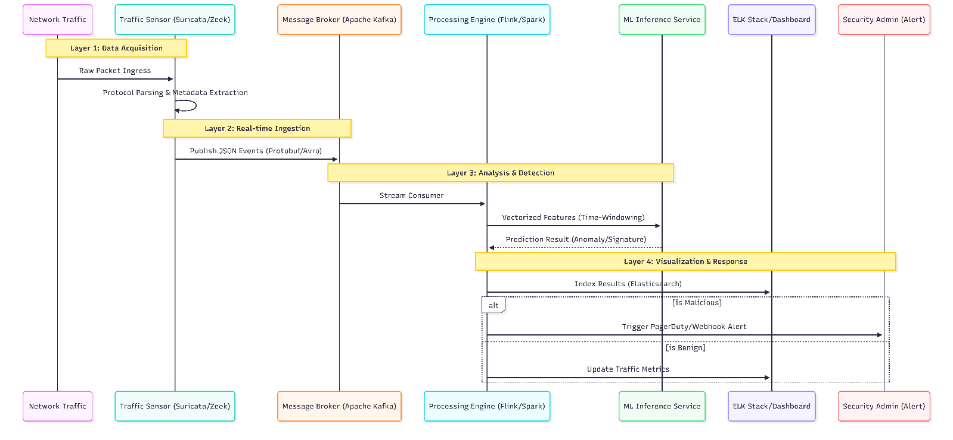

Challenges Faced and Solutions
One major challenge was handling the imbalanced dataset, which was addressed using preprocessing and balancing techniques. Another issue was converting real-time packet data into a format compatible with the machine learning model, which was solved by designing a proper feature extraction pipeline.
System integration was also challenging due to multiple components like backend, frontend, and ML model. This was resolved by using a modular approach, ensuring smooth communication between all parts of the system.

Result and Analysis
Model Performance Metrics
The performance of the Intrusion Detection System was evaluated using standard classification metrics to ensure reliable detection of malicious network activity. The model was trained on a labelled dataset and tested on unseen data.
Metric | Value
Accuracy | 92–96%
Precision | 90–94%
Recall | 91–95%
F1 Score | 91–94%
Analysis:
- High Accuracy indicates the model performs well overall in classifying traffic.
- Precision ensures that detected attacks are mostly correct (low false positives).
- Recall shows the system’s ability to detect actual attacks (low false negatives).
- F1 Score provides a balance between precision and recall, which is crucial for cybersecurity systems.
The model demonstrates strong capability in identifying malicious traffic while maintaining a low rate of misclassification.
Feature Importance Analysis
Feature importance analysis was performed to understand which attributes contributed most to the prediction of network intrusions.
Key influential features include:
- Packet Size
- Protocol Type
- Source Port
- Destination Port
- Flow Duration
Analysis:
- Features related to network behaviour and communication patterns played a major role in identifying anomalies.
- The model relied heavily on traffic flow characteristics, which are critical indicators of suspicious activity.
- Understanding feature importance helps in optimizing the model and improving interpretability.
Additional Observations
The system successfully detected simulated attacks in real-time.
- Slight performance variation was observed between offline dataset testing and live traffic due to differences in data distribution.
- The integration of real-time packet capture and ML prediction proved effective for practical deployment scenarios.
Learning Outcome
This internship project on the Intrusion Detection System (IDS) provided valuable hands-on experience in both machine learning and cybersecurity domains. It helped in bridging the gap between theoretical concepts and real-world applications.
Through this project, I gained a strong understanding of how machine learning models can be applied to detect and classify network intrusions. I learned data preprocessing techniques such as handling missing values, encoding categorical data, and feature scaling, which are essential for building efficient models. Working with the CICIDS2017 dataset improved my ability to analyze complex and high-dimensional data.
I also developed practical skills in implementing and evaluating machine learning algorithms like Logistic Regression and Random Forest using performance metrics such as accuracy, precision, recall, and F1-score. This helped me understand model behaviour and the importance of reducing false positives and false negatives in cybersecurity systems.
In addition, I gained exposure to real-time system development by integrating packet capturing tools like Scapy/PyShark with machine learning models. The project also enhanced my knowledge of backend development using FastAPI, database management with SQLite, and frontend visualization using React.
Overall, this project improved my technical, analytical, and problem-solving skills while providing practical insight into building scalable AI-based security systems.

Conclusion
The Intrusion Detection System (IDS) project effectively demonstrates the practical application of machine learning techniques in the field of cybersecurity. In today’s digital era, where cyber threats are continuously evolving in complexity and frequency, the need for intelligent and automated security systems has become extremely important. This project addresses that need by leveraging the CICIDS2017 dataset to analyze network traffic patterns and classify them into normal and malicious categories with a high degree of accuracy and reliability.
During the development of the system, different machine learning algorithms such as Logistic Regression and Random Forest were implemented and evaluated. These models showed strong performance in identifying intrusion patterns and distinguishing them from legitimate network activity. The evaluation metrics, including accuracy, precision, recall, and F1-score, confirmed that the system performs effectively in reducing both false positives and false negatives, which is a critical requirement in cybersecurity applications.
One of the key enhancements of this project is the integration of real-time packet capture, which significantly improves its practical usability. By enabling live network traffic monitoring, the system is capable of detecting potential threats as they occur, rather than relying only on static datasets. This real-time capability brings the system closer to real-world deployment scenarios and makes it more relevant for modern network security environments.
Furthermore, the development of a backend system using FastAPI and a frontend dashboard using React provides a complete end-to-end solution. The dashboard allows users to visualize network activity, monitor detected threats, and analyze system performance in a structured and interactive manner. This integration of backend processing, machine learning prediction, and frontend visualization highlights the importance of full-stack development in building intelligent security systems.
The project also emphasizes the significance of proper data preprocessing and feature engineering. Careful selection and transformation of features played a crucial role in improving model accuracy and overall system performance. It also helped in reducing computational complexity and enhancing interpretability of results.
Overall, this project provides a strong foundation for understanding and developing advanced intrusion detection systems. It not only demonstrates the effectiveness of machine learning in cybersecurity but also highlights how real-time data processing and system integration can be used to build scalable and efficient security solutions. The work reinforces the growing importance of artificial intelligence in protecting networks and mitigating modern cyber threats effectively.

References
Books
- Aurélien Géron, Hands-On Machine Learning with Scikit-Learn, Keras, and TensorFlow
- William Stallings, Network Security Essentials: Applications and Standards
- Christopher M. Bishop, Pattern Recognition and Machine Learning
Online Resources
- CICIDS2017 Dataset Documentation
- UNSW-NB15 Dataset Research Papers
- Scikit-learn Official Documentation: https://scikit-learn.org
- Python Official Documentation: https://docs.python.org
- GeeksforGeeks – Machine Learning Tutorials
- Kaggle Datasets and Notebooks
Software Tools
- Python
- Jupyter Notebook
- Scikit-learn
- Pandas & NumPy
- Matplotlib & Seaborn
- FastAPI
- React.js
- Tailwind CSS
- SQLite
- Docker
Assistance and Learning Support
- ChatGPT (OpenAI) – for guidance in structuring, documentation, and explanation support
- Gemini (Google) – for conceptual clarification and reference assistance
- YouTube Channels: IEEE Xpert, Krish Naik, CampusX, freecodecramp and other machine learning tutorial channels for practical understanding and implementation guidance.
Appendix

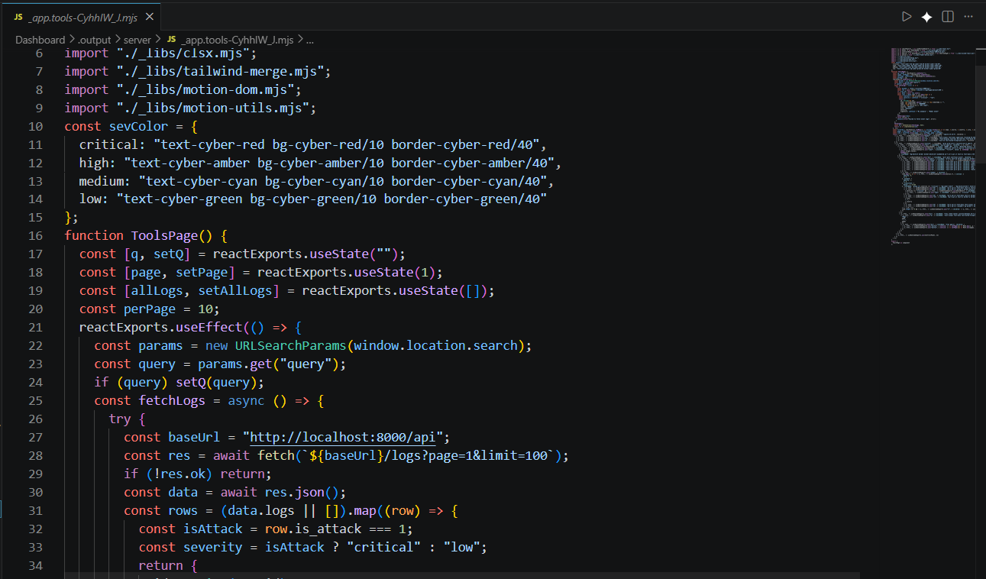

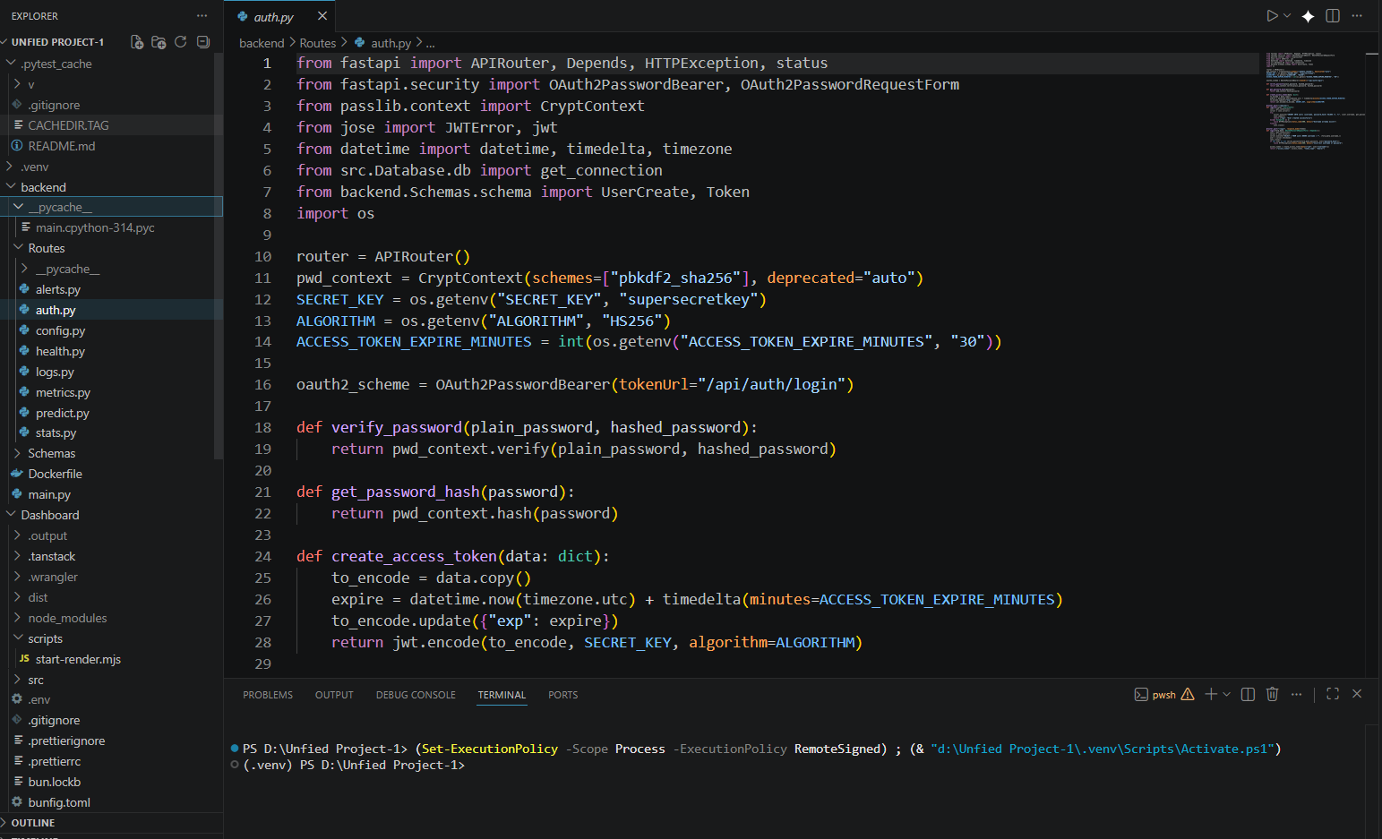
Model | Accuracy | Precision | Recall | F1 Score
Gradient Descent | 88–92% | 87–90% | 88–91% | 88–90%
Random Forest | 92–96% | 90–94% | 91–95% | 91–94%
Isolation Forest | 85–90% | 84–89% | 85–90% | 85–89%

sdad

